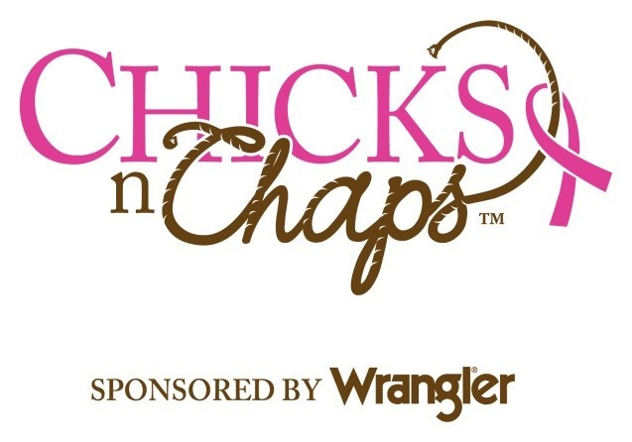
2018 Chicks n Chaps™
Women’s Rodeo Clinic
~Lewiston Roundup Grounds~
~Friday, September 7, 2018~
~Check-In 2:30-4:00~
~Late Check-in available by notification~

Please Print Clearly – Incomplete or illegible forms will not be processed.
Contact Information (Registrants cannot be transferred or exchanged) (Must be over 21)
Participant Name___________________________________ Birth Date___/___/___ Address________________________________City_____________St___Zip________ Phone ( )______-_______ Alternate Phone ( )______-_______
How did you hear about Chicks n Chaps™_________________________________
Contact E-Mail* for event updates__________________________________________
Chicks n Chaps™ Registration~ No refunds or exchanges. No entries day of event.
Must be registered prior to event ~ Ages 21 and over ONLY
❑ Entry Fee $70.00. Entry deadline is August 24, 2018
❑ I would like to donate to Chicks n Chaps™ $______ in addition to my registration fee.
T-shirt size: please circle one: XS S M L XL 2XL 3XL 4XL (Ladies Cut)
**On-line Registration with Credit Card payment available at
https://lra_cnc2018.eventbrite.com

Consent & Indemnification:
I understand that I am a participant in the Chicks N Chaps™ event. I hereby release Lewiston Roundup Association of Nez Perce County, its officers, staff, volunteers and sponsors, Sankey ProRodeo Company, and organizers of Chicks N Chaps™ from liability for injury, loss or damage associated with participation in this event. I certify I am over the age of 21. I understand the risk of this event, accept all responsibility and agree to participate.

Signature_______________________________ Date___________
Photograph Release I give Chicks n Chaps™ permission to use photo(s) of myself in this event for promotional purpose, should the occasion arise.

Signature_______________________________ Date___________

Mail Registration with payment to:  LRA  PO Box 314  Lewiston ID, 83501 | For more further information please call  Kristin Kemak 208-790-9995  kriskemak@gmail.com
Chicks n Chaps™ is a qualified 501©3 nonprofit organization

